When using the data extracted from the redcap database in Tableau, we could use the web data connector function that is built in Tableau to connect the server(firstly need to set the Tableau external modules and utilization of API in Redcap seeting); but not when the data stored in the redcap database is too large; it is too time-consuming to load the data.

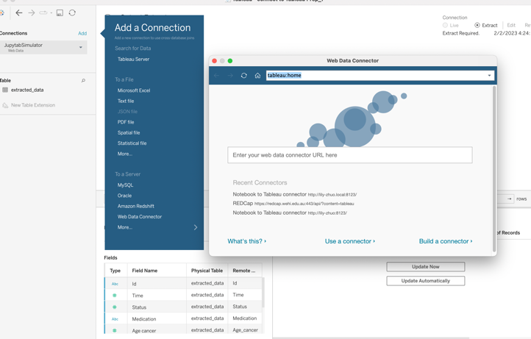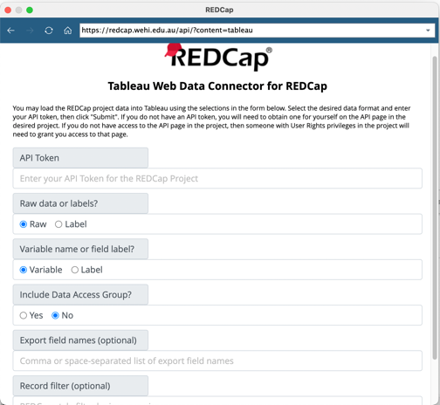

Here we tried an intermediate: Jupiter notebook and use the package of 

1. Get the exported data from redcap database
2. Clean and preprocess data in the format used to draw KM curve
3. The final preprocessed dataframe is sent to web server
4. Tableau access data through the web server

Reference:<https://github.com/CFMTech/Jupytab>

Follow the instruction to set the environment to use jupytab

Two main components:

* Jupytab: API expose dataframe and function from notebook

Command in terminal:

conda create -n jupytab-notebook-env python=3.7

conda activate jupytab-notebook-env

conda install jupytab=0.9.11

conda install ipykernel

python -m ipykernel install --user --name jupytab-simulation-demo

* Jupytab-server: provide server that connect to tableau and along with configuration file

Command in terminal

conda create -n jupytab-server-env python=3.7

conda activate jupytab-server-env

conda install jupytab-server=0.9.11

Then we write the logic of getting the export data and prepare data to extracted data format inside the jupyter notebook and note to change the kernel we installed with required dependency

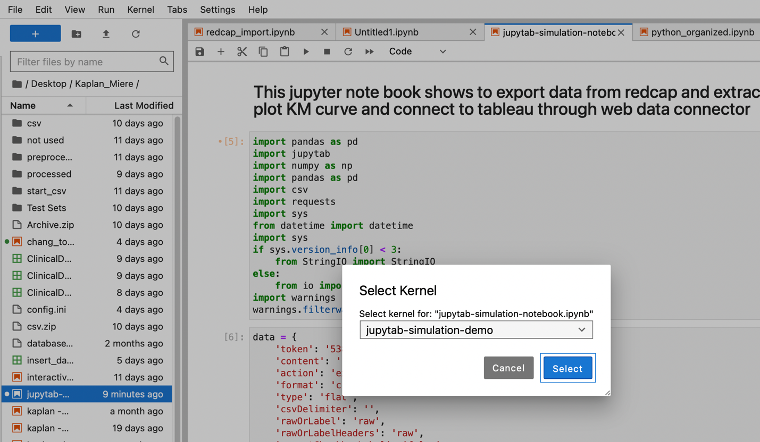

In the notebook, there are two parts of coding is necessary to make the dataframe that used as data source in Tableau:

1. Load dataframe with Tables method in Jupytab so that it can be exposed to Tableau



1. Declare our dataframe’s schema and how the data exported when notebook executed by juptab server

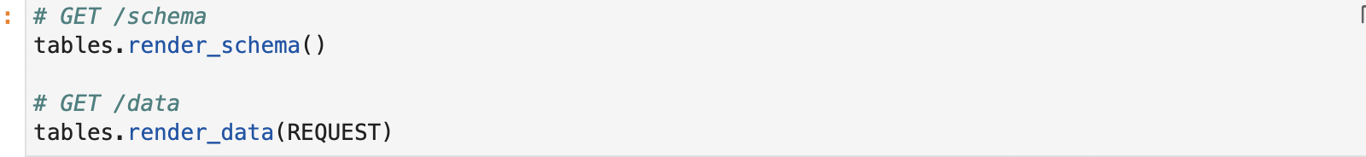

Before running the server, the configuration file(config.ini) need to be created.

And more setting can refer to https://github.com/CFMTech/Jupytab#configuration-file

And The command for running the server is

jupytab --config=path_to_config.ini

server In the terminal, it will shows content

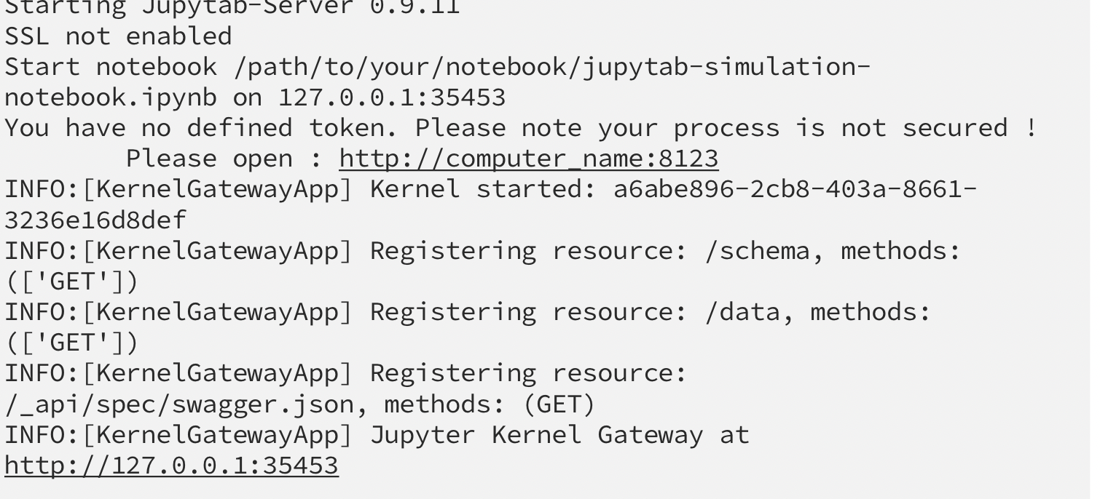

And may need wait few minutes to finish the process in jupyternotebook until the terminal shows log below then can go to Tableau to connect data

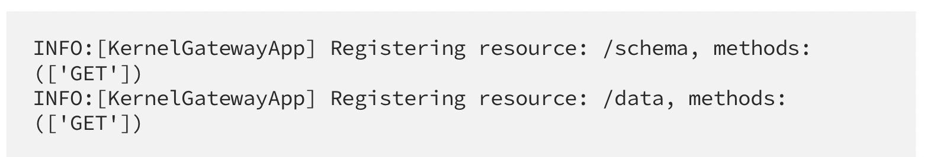

In Tableau, choose Web Data Connector-> enter the address show in the terminal and press enter to select the jupyternotebook-> Explore in Taleau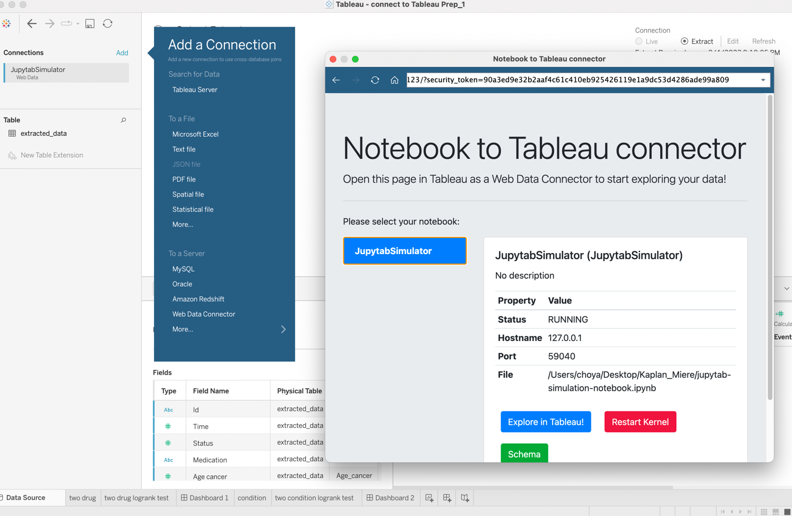

Reference: <https://towardsdatascience.com/interactive-simulation-with-tableau-and-jupytab-c26adb1be564>